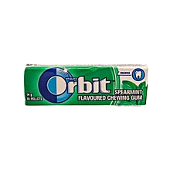
GOOD DESIGN
- Its eye catching;has a combination of good colors
- Its well detailed showing what it contains i.e it tells that it’s chewing gum and the amount of pellets inside the wrap and also tells its flavor
- Has pictures of its ingredient (mint plants) and a picture of a tooth showing how one feels while chewing them
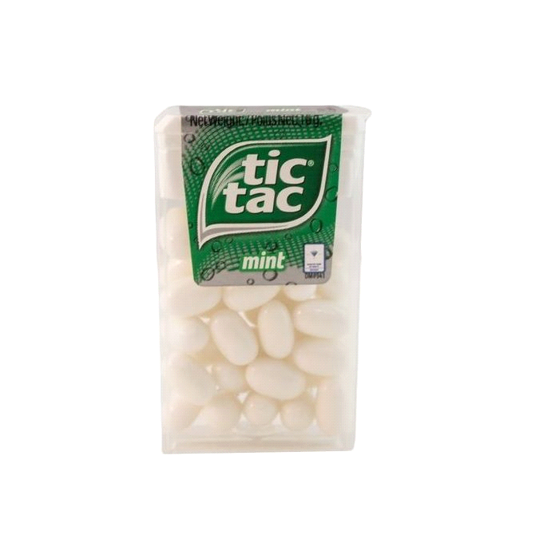
BAD DESIGN
- Its dull(not appealing to the eye)
- Has only one obvious detail i.e mint...which is the main content and we know and its not even telling us what that is…it could be even medicine tablets for example….
- Has zero pictures of what it contains…no mint plant pictures just the brand logo

